**Week 1:**

Develop a RESTful API for a "To-Do List" application using Node.js.

Deliver:

* Fully functional CRUD operations (Create, Read, Update, Delete) for task.
* Middleware implementation for request validation.
* Code repository with structured folder organization and documentation.
* Document execution screenshot.

Code Repository: <https://github.com/Akriti987/Weekly_Tasks.git>

**Execution Documentation for Node.js To-Do Application**

This document outlines the execution steps and functionalities of the provided Node.js application for managing tasks.

**Prerequisites:**

* Node.js and npm installed on your system.
* A code editor or IDE for editing JavaScript code. (VS Code)

**1. Setting Up the Project:**

1. Clone the repository.
2. Install dependencies: run ‘**npm install’** to install the required dependencies listed in the ‘**package.json’** file.

**2.** Database Used **(MongoDB)**

**3. Running the Application:**

Start the server by **node server.js** in the terminal inside the **/Week1/src** folder. This will start the Node.js on the specified port (default: 3000).

**4. API Endpoints:**

The application provides several API endpoints for managing tasks:

* **GET /tasks:** Retrieves a list of all tasks stored in the database.
* **GET /tasks/:id:** Retrieves a single task by its ID.
* **POST /tasks:** Creates a new task. The request body should contain **title** and **description** properties for the new task. (middleware validation)
* **PUT /tasks/:id:** Updates an existing task by its ID. The request body should contain the updated properties for the task.
* **DELETE /tasks/:id:** Deletes a task by its ID.

By following these steps and understanding the functionalities, you can effectively use this Node.js application to manage your tasks through API requests.

**Execution Screenshots:**

1. Running the App

1. Requests (POST, GET, PUT, DELETE)

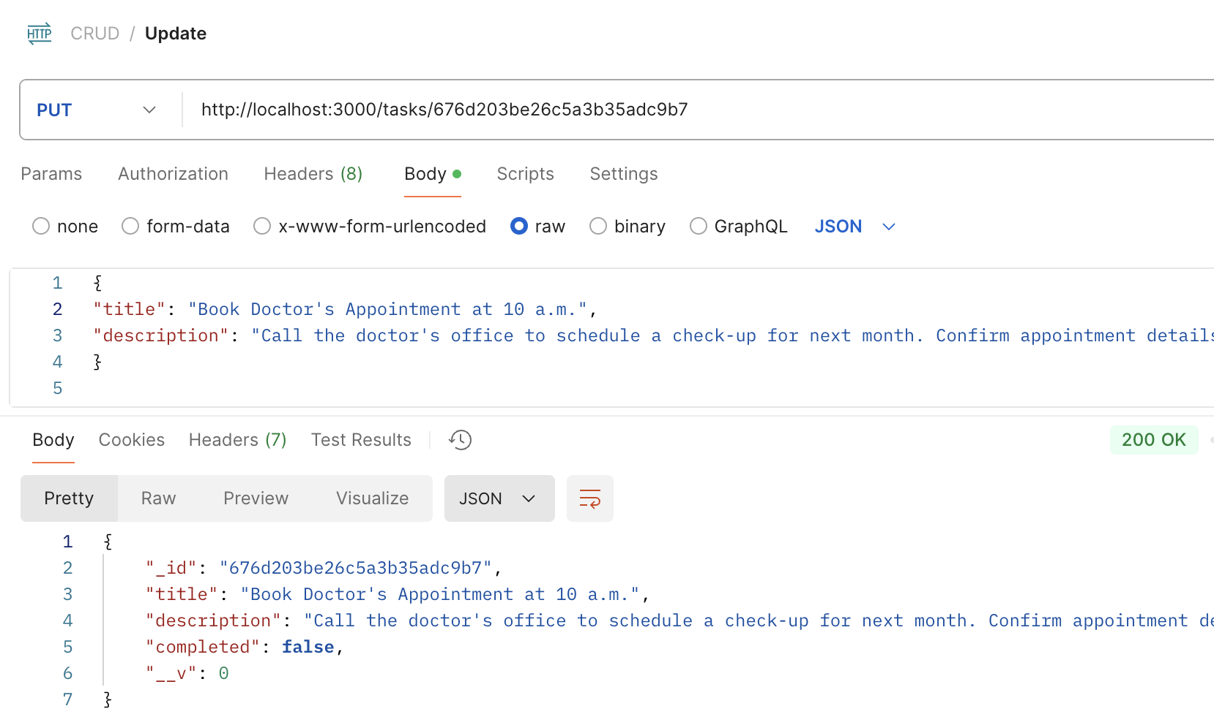

1. Creation of entries in Database

1. Code Snippets



